Part V

**Ensure Access to Affordable, Reliable, Sustainable and Modern Energy for All**

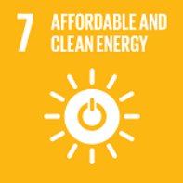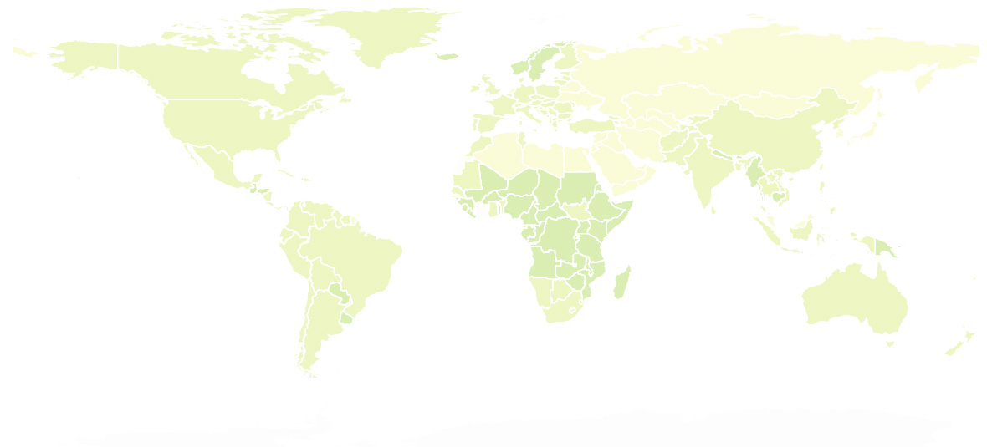The world is making progress towards Goal 7—”Ensure access to affordable, reliable, sustainable and modern energy for all” —with encouraging signs that energy is becoming more sustainable and widely available. Access to electricity in poorer countries has begun to accelerate, energy efficiency continues to improve, and renewable energy is making impressive gains in the electricity sector. However, measures should be continuously taken in terms of improving energy efficiency and increasing the proportion of renewable energy and clean energy.

**Provide policy, technical and economic support to economically backward countries**

Today, nearly 9 out of 10 people now have access to electricity, but reaching the unserved will require increased efforts. It is suggested to provide policy, technical and economic guidance for underdeveloped area, with local condition and energy sources taken into account.

In the process of industrialization in backward areas, special attention should be paid to the promotion and use of renewable energy. The international society need to take the responsibility for improve the energy structure of underdeveloped regions, in avoidance of the increasing of the use of the inefficient use of solid biomass, such as the burning of wood, charcoal or other organic matter.

**Improve energy efficiency by promoting technical exchanges**

The GDP of countries in the heyday of industrialization is very dependent on energy consumption. While economic development, these countries are also obliged to take the responsibility of improving the quality of development and protecting the global environment.

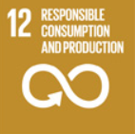For this, on the one hand, energy efficiency must be improved. Improving energy efficiency—along with increasing energy access and affordability—is central to the global goal of reducing greenhouse gas emissions.In another hand, the government should progress in the electricity sector must extend to transportation and heating to meet an ambitious renewable energy target.

**Promote an environmentally friendly lifestyle in developed countries**

Developed countries have done a good job in the use and promotion of plot energy and renewable energy, which is due to the high social cost of high technology and pollution. However, from the perspective of per capita energy consumption, there is still room for improvement in developed countries. Take the United States as an example. The energy consumption per capita in the United States is ten times that of many developing countries. We need to promote an environmentally friendly lifestyle in developed countries.



Sincerely,